1.The sum of the total price of all pizza orders:

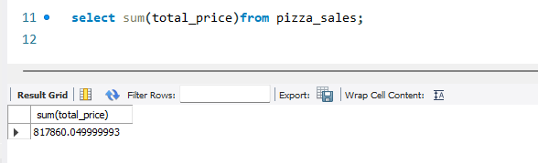

Revenue (name change):

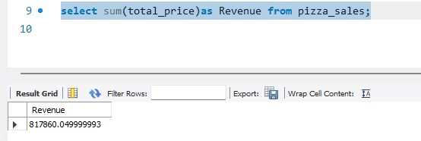

2. the average amount spent per order, calculated by dividing the total revenue by the total number of order .

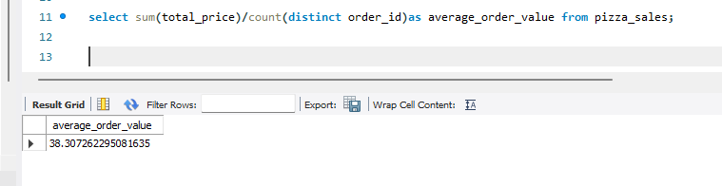

4. the total number of orders placed.

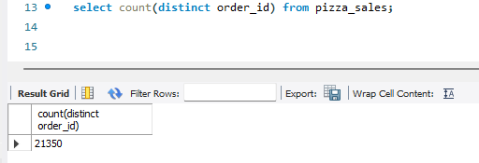

3. the sum of the quantities of all pizzas sold.

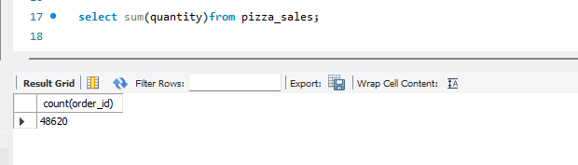

5. the average number of pizza sold per order, calculated by dividing the total number

